Victorian Primary Care Partnerships

Submission to Victorian State Disability Plan 2017-2020

June 2016

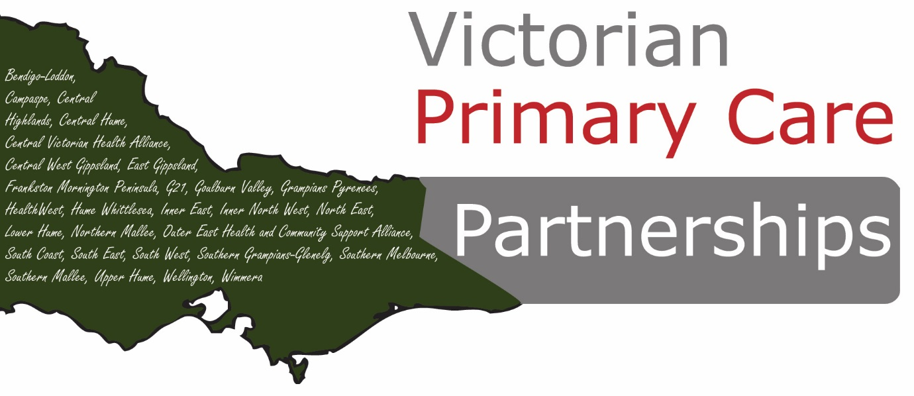

Contents
About Primary Care Partnerships 3
The role of PCPs 4
Introduction 6
Definition of disability 6
Disability and the health system 7
A meaningful strategy 7
Partnerships as an essential platform 7
The role of service coordination 8
Care coordination and e 9

About Primary Care Partnerships
Primary Care Partnerships (PCPs) are established networks of local health and human service organisations. They collaborate together to find smarter ways of making the health and community sector system work better, so the health and wellbeing of their communities is improved. Since they were introduced by the Victorian Government in 2000, PCPs have become a vital component of the Victorian healthcare system.
In the 15 years of operation PCPs have grown significantly, in both size and reputation, as more and more health and social services and community groups join them in the quest to deliver better health and wellbeing outcomes for Victorians. Today, PCPs facilitate partnerships with a wide range of health and social service providers and community groups; and they support collaboration and service integration. Most importantly, they play a key role in enhancing the wellbeing of people within our local communities.
There are now 28 PCPs around Victoria that connect more than 800 organisations across many different sectors. These diverse organisations are working together to plan around the needs of the community, to share their skills and expertise, and align their efforts. In bringing these health and social service organisations together, PCPs find new ways to collaborate and share valuable learnings, research and information. When it comes to the health and wellbeing needs of the community PCPs also enable more effective integrated planning, and develop the service system through co-ordination and integrated care as well as by making better use of data, evidence-informed interventions and a common planning framework.
PCPs are delivering real results – particularly, better health and social outcomes for community members – at the local level. Indeed, a comprehensive evaluation report found that PCPs have: improved integrated planning, improved service co-ordination, increased organisational capacity and learning for health promotion, delivered economic benefits and resource efficiencies and contributed to healthier communities
The Primary Care Partnership platform is used extensively by the Department of Health and Human Services to roll out new initiatives in the areas of service coordination, integration and chronic disease management. The platform is also pivotal in the delivery of prevention and health promotion work across Victoria.

The role of PCPs
The strategy goal for PCPs is strengthen collaboration and integration across sectors by 2017, in order to:
- maximise health and wellbeing outcomes
- promote health equity
- avoid unnecessary hospital presentations and admissions.
It is a requirement that PCP action over 2013–17 is shaped by the following seven guiding principles:
- Tackling health inequities
- Person and family centred
- Evidence-based and evidence-informed decision making and action
- Cross-sector partnerships
- Accountable governance
- Wellness focus
- Sustainability (including optimal use of technology)
The PCP program logic for 2013–17 has three integral domains:
- Early intervention and integrated care
- Consumer and community empowerment
- Prevention
Within local PCPs, all work is underpinned by core service coordination principles as outlined in the Victorian Service Coordination Practice Manual2:
- Central focus on consumers
- Partnerships and collaboration
- The social model of health and the social model of disability
- Competent staff
- Duty of care
- Protection of consumer information
- Engagement with a broad range of service sectors
- Consistency in practice standards
Recommendations
- Work with member organisations and Medicare Locals (now PHNs) to strengthen integration and communication practices among providers (including between state-funded and private providers) to facilitate consumer transitions between services and reduce the need for consumers to retell their stories.
- Facilitate advancement of Victorian service coordination practice manual 2012 implementation to broader health and wellbeing agencies
- Work with member organisations to identify and address access barriers, particularly for the identified local priority group
- Develop and implement local agreements for care planning, care coordination and case conferencing to ensure systemic care planning (including e-care planning) within and across organisations
- Facilitate implementation of local agreements and systematic interagency care pathways for defined consumer cohorts using evidence-based guidelines
- Facilitate development and implementation of a robust identification and recall system for people with complex and multiple needs for review and quality control
- Facilitate continued system improvements for early identification and intervention for priority target groups
- Continue to strengthen e-health initiatives

Introduction
Victorian Primary Care Partnerships (VicPCP) welcomes the opportunity to provide feedback on the discussion paper of the Victorian State Disability Plan 2017-2020. The State Disability Plan is an important opportunity to set out a vision for how the Victorian community and service system supports participation of and builds opportunities for people with disability.
As the discussion paper noted, the roll-out of the NDIS will change the Victorian Government’s role and responsibilities in relation to people with disability. It will also bring new challenges for how the mainstream service system will interface with the NDIS to support NDIS participants and people who are not eligible for individual NDIS support or choose not to access it. PCPs have an important role to play in enhancing the capacity of existing health and human services to meet the needs of people with disability and providing a space for agencies providing NDIS services to come together to plan and coordinate their services.
PCPs can also provide an effective platform for encouraging consumer engagement in service design and delivery and…
Several PCPs have identified people with disability as priority target populations for their work. Others identify mental health, dementia and other conditions as early intervention and integrated care priorities.

Definition of disability
The State Disability Plan is an opportunity to provide an overarching vision for how we support people with disability to live and participate equally in community life. Achieving this vision requires a plan that is inclusive of all Victorians with a disability.
There is no suggested definition of disability in the discussion paper. Vic PCP recommends the plan adopt a broad and inclusive definition that includes people living with mental illness, dementia and other chronic conditions.
This broad definition is likely to be particularly important in the context of the transition to the NDIS, as some people without a ‘permanent disability’ will not qualify for individual support packages, and will need access to alternative supports to enable them to live full and meaningful lives.

Disability and the health system
The health system does not always effectively meet the needs of people with disability, especially people whose needs are complex. Changes can be made to improve access and quality of care for people with disability who need support from mainstream services.
People with disability experience significantly poorer health outcomes than other Australians. For example, almost half of people aged 15-64 years with severe or profound disability report fair or poor health, compared to 5 per cent of people without disability.
People with disability aged 15-64 are also more likely to be daily smokers, to be overweight or obese and to engage in a very low level or no exercise. About 42 per cent of people with disability aged 16-64 years have seriously thought about suicide.
However, health care for people with disability can sometimes exhibit a lack of communication, poor understanding of the everyday and special health needs of people and poor procedures for the delivery and integration of services.

A meaningful strategy
To be meaningful, the strategy must be more than a set of aspirational statements. It requires agreed targets and dedicated resourcing.
As noted in the companion document to the discussion paper, it is important that the plan is owned by all government departments, and not seen as the responsibility of one area.

Partnerships as an essential platform
The NDIS is not a health scheme. However it will intersect with the health system on a number of levels. To ensure care for NDIS participants and other people with disability is integrated and seamless, agencies will need to work closely together to monitor and address issues as they arise.
Effective partnerships will be crucial to ensure that all people with disability receive the right support, in the right place at the right time.
Many people with disability come into contact with numerous health and community agencies including health and mainstream community services. To minimise duplication and ensure most appropriate care, mainstream health and community service providers need to be equipped to respond appropriately and inclusively and make appropriate referrals.
PCPs are well placed to work with stakeholders to develop a more integrated service system and strive towards a more consistent, coordinated and timely responses that result in enhanced care and improved outcomes for people in the community.

The role of service coordination
Service coordination places consumers at the centre of service delivery to maximise their opportunities for accessing the services they need. Service coordination enables organisations to remain independent of each other, while working in a cohesive and coordinated way to give consumers a seamless and integrated response.
Primary Care Partnerships have 15 years of expertise in service coordination having worked extensively in this area to ensure better access to services across a range of health and community services. Our experiences have taught us that improvements in service coordination practices are critical to reducing the burden that ill-health places on individuals, families and the community. Timely access to appropriate services is the key to ensuring better outcomes.
Service coordination can offer many benefits to consumers and service providers, including:
- Improved access to assessment and coordinated shared care/case planning clarity regarding who is involved in service provision and what their responsibilities are to meet the consumer’s goals
- Reduced duplication of assessments and services as well as identification of service gaps
- Documented practice standards for the elements of service coordination including; initial contact, initial needs identification and shared care/case planning, providing a common language between services
- Improved consistency and quality of consumer information through the use of common tools such as the Service Coordination Tool Templates which have increased efficiency by combining over 300 different versions of templates.
Service Coordination in Victoria is documented in the Victorian Service Coordination Practice Manual. The manual and associated resources were designed by PCPs for managers and service providers involved in the implementation of service coordination. The resources aim to provide an overarching service coordination framework applicable to a range of sectors and services including:
- Aboriginal community-controlled organisations (ACCO)
- Ambulance Victoria
- disability services
- family violence services
- general practice
- health
- housing
- mental health
- multicultural and ethno-specific services
- welfare and community services
- youth and family services

Case study: Physical health matters too
Physical Health Matters Too represents an integrated approach to addressing the physical health needs of people with a serious mental illness. Across the North East and Hume Whittlesea Primary Care Partnerships, a number of mental health agencies, have now introduced physical health screening, as a way of assisting and empowering clients to take some control over their health. Workers will now ask clients a series of questions to help them think about different areas of their health and if further follow up and advice is required a referral can be made to a local service such as a GP or community health service. For more information see Appendix 2.

Care coordination and eReferral systems
E-health as a domain is now moving beyond secure messaging into the complex area of shared care planning. Being able to access, contribute and use ‘live’ documents in partnership with consumers and service providers is something we need to strive for, and requires greater support (and pressure) from the Victorian Government.
Care coordination is greatly enhanced where there are high levels of IT connectivity which comply with the National E-Health Transition Authority (NEHTA) Standards. There are a number of electronic client management systems that enable better connectivity for supporting services. S2S and Connecting Care are the ones that are used by the majority of PCP member agencies in Victoria. S2S and Connecting Care enable secure messaging between agencies. s2s also has the capacity to have an interactive shared support plan between agencies supporting a consumer. PCPs are well placed to assist local health providers to become more e-referral literate and recommend.

Case Study: Promoting positive health outcomes for people with disability
Low health literacy has been linked to poor health outcomes. Adults with low health literacy are more likely to be admitted to hospital and less likely to participate in preventative health programs such as regular breast screens. Individuals with low health literacy have also been shown to be less likely to continue taking a medication.
Promoting positive health outcomes through robust health literacy is one of the most significant ways in empowering communities. The G21 Health & Wellbeing Pillar is committed to maximising the opportunities for community members with disabilities to exercise choice and control.
This project explores participant’s health information and health communication needs, recognising that participants will include people with one or more disabilities and health issues and health workers or parents providing support to people with disabilities. The project also works towards understanding:
- The issues and concerns that people with disabilities have when accessing health information.
- Improving the understanding around what kind of health information works for people with disabilities and in what settings.
- Understanding from a health worker perspective what other health professionals they need to liaise with particular health issues.

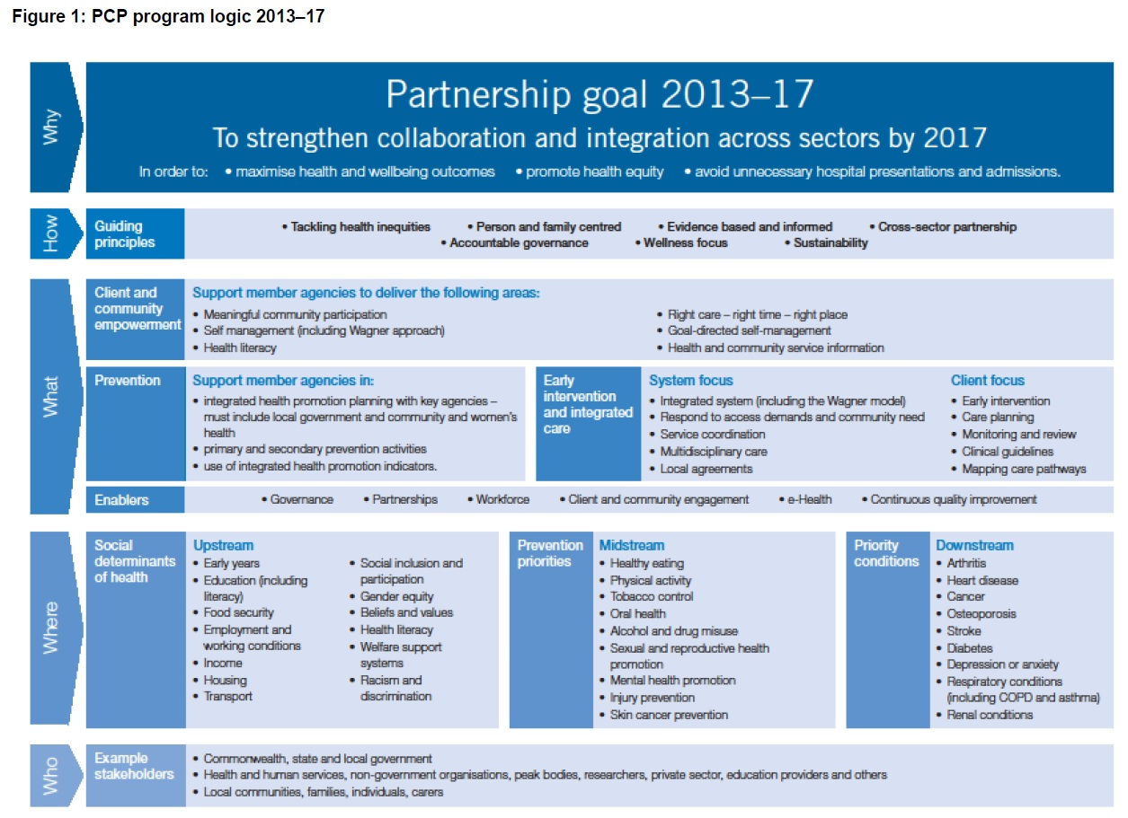

Department of Health (2011) Primary Care Partnerships: Achievements 2000-2010.
AIHW, Bulletin 83: Health of Australians with disability; health status and risk factors, 2010, pg 1.
AIHW, Bulletin 83: Health of Australians with disability; health status and risk factors, 2010, pg 2.

